High Level Design (HLD) Concrete Compressive Strength Prediction

**Revision Number: 1.**

**Last date of revision: 27/11/2022**

**Document Version Control**

|  |  |  |  |
| --- | --- | --- | --- |
| Date Issued | Version | Description | Author |
| 27/09/2021 | 1.0.1 | Initial HLD – V1.0.1 | Sree Harsha K |

### Contents

Abstract 4

1. Introduction 5
   1. Why this High-Level Design Document? 5
   2. Scope 5
   3. Definitions 5
2. General Description 6
   1. Product perspective 6
   2. Problem statement 6
   3. Proposed solution 6
   4. Technical requirements 6
   5. Data requirements 7
   6. Tools and technologies used 8
   7. Constraints 8
3. Design Details 9
   1. Process flow 9
   2. Deployment process 10
   3. Event log 10
   4. Error handling 10
   5. Performance 10
   6. Reusability 11
   7. Application compatibility 11
   8. Resource utilization 11
   9. Deployment 11
   10. User interface 12
4. Conclusion 13

# Abstract

Being one of the most frequently used building materials, the quality of concrete is determined by its compressive strength, which is measured by crushing a concrete cube or a cylinder until it starts cracking and crushed. The pressure at which the concrete cube or a cylinder starts cracking and eventually crushes is called the Concrete compressive strength and is measured in megapascals (MPa). It takes a long period of 28 days to test like this. With the help of Data science and the Machine learning technology, I developed an application, which allows an engineer to determine the strength of a concrete in just a few seconds of time.

# Introduction

## Why this High-Level Design Document?

The purpose of this High-level document (HLD) is to describe the design of the project in detail which can be used as a reference manual.

The HLD will:

* Present all the design aspects and define them in detail.
* Describe the user interface being implemented.
* Describe the software interfaces.
* Describe the performance requirements.
* Include design features and the architecture of the project.

## Scope

The HLD document present the entire structure of the project in parts, such as the data ingestion, data pre-processing, solution development and the deployment part along with their respective architectures. This uses non- technical to mild technical terms which should be understandable to the administrators of the system.

## Definitions

|  |  |
| --- | --- |
| Term | Description |
| EDA | Exploratory Data analysis |
| IDE | Integrated Development  Environment |
| PaaS | Platform as a service |

# General Description

* 1. **Product perspective**

The Concrete compressive strength predictor is a machine learning based regression model which will help us to predict the compressive strength of a concrete based on its ingredients, which will be used to determine its quality by the engineers.

* 1. **Problem statement**

The quality of concrete is determined by its compressive strength, which is measured using a conventional crushing test on a concrete cylinder. The strength of the concrete is also a vital aspect in achieving the requisite longevity. It will take 28 days to test strength, which is a long period. So, what will we do now? We can save a lot of time and effort by using Data Science to estimate how much quantity of which raw material we need for acceptable compressive strength.

* 1. **Proposed solution**

The solution proposed here is a web application, which takes the details of the main ingredients of a concrete specimen which contributes to its compressive strength and those details will be taken by a machine learning model in the backend, which predicts the compressive strength in MPa and displays in the front-end page to the user.

* 1. **Technical requirements**

I used python version 3.9.12 with some important libraries to develop a machine learning model, which accurately predicts the compressive strength of a concrete based on its details.

Then, the model is used as a back-end software for a front-end web application which can be used by the users.

* 1. **Data requirements**

For training and testing the model, I used the public data set available in

Kaggle, “Concrete Compressive Strength Data Set” by Ahiale Darlington.

URL - [https://www.kaggle.com/elikplim/concrete-compressive-strength-data-](https://www.kaggle.com/elikplim/concrete-compressive-strength-data-set) [set](https://www.kaggle.com/elikplim/concrete-compressive-strength-data-set)

Data dictionary is as follows:

|  |  |  |  |
| --- | --- | --- | --- |
| Name | Data Type | Measurement | Description |
| Cement | Quantitative | kg in a m3 mixture | Input variable |
| Blast Furnace Slag | Quantitative | kg in a m3 mixture | Input variable |
| Fly Ash | Quantitative | kg in a m3 mixture | Input variable |
| Water | Quantitative | kg in a m3 mixture | Input variable |
| Superplasticizer | Quantitative | kg in a m3 mixture | Input variable |
| Coarse Aggregate | Quantitative | kg in a m3 mixture | Input variable |
| Fine Aggregate | Quantitative | kg in a m3 mixture | Input variable |
| Age | Quantitative | Days (1~365) | Input variable |
| Concrete Compressive  Strength | Quantitative | megapascals (MPa) | Output variable |

* 1. **Tools and technologies used**



* Jupyter notebook is used for EDA and experimentation with various ML algorithms with the help of pandas, numpy, matplotlib, seaborn, scikit learn, statsmodels and xgboost libraries.
* Visual Code is an IDE used for development and deployment of the solution with logging. Used python version 3.7 and libraries include logging, pandas, NumPy, scikit learn, stats models, XGBoost, joblib, flask and

html .

* GitHub is used as a version control system.
* Deployed on web using Gunicorn and Heroku.
  1. **Constraints**

The Concrete Compressive Strength Prediction system must be user friendly, errors free and users should not be required to know about any of the workings.

# Design details

* 1. **Process flow**

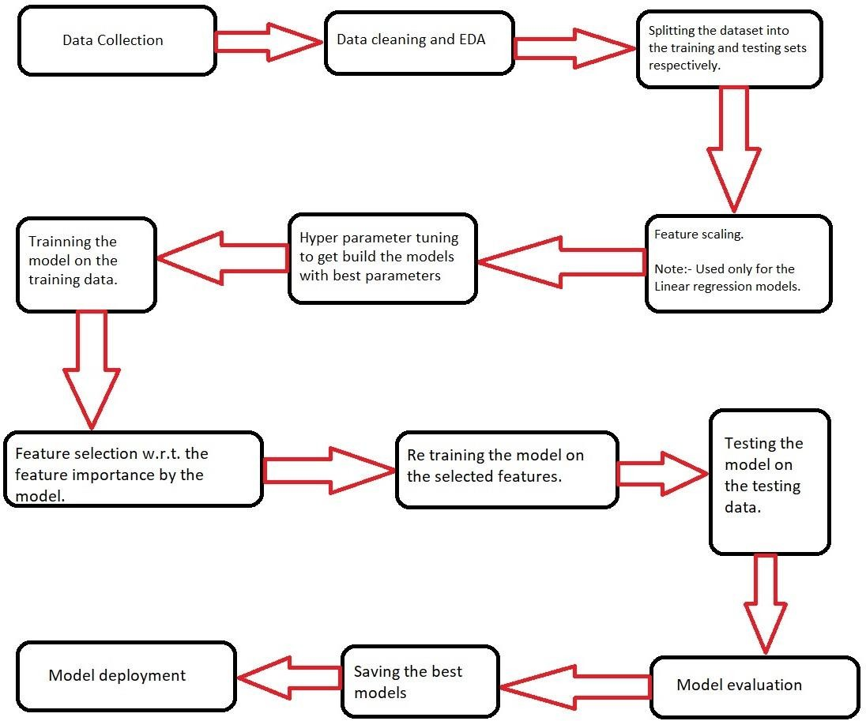

* 1. **Deployment process**

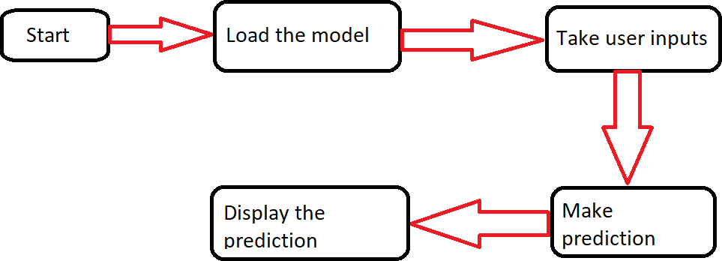

* 1. **Performance**

The ML based Concrete compressive strength predictor application is used for predicting the compressive strength of a concrete based on its age and its ingredients. So, it should be as accurate as possible, so that it will not mislead the concerned authorities (like civil engineers, architects, construction companies, etc,). Also, the model retraining is very important to keep it relevant if the new variants of concrete are designed in future or to improve the performance.

* 1. **Reusability**

The code written and the components used have an ability to be reused without any problem.

* 1. **Application compatibility**

The different components or modules of this project use python version 3.7 as their interface between them. Each component has its own task to perform, and it is the job of the python version to ensure proper transfer of the information.

* 1. **Resource utilization**

In this project, any task may likely to use all the processing power available in the system, until it is accomplished.

* 1. **Deployment**

I deployed the application on web using Heroku with Gunicorn

URL - https://compressivestrength.herokuapp.com/



* 1. **User interface**

I designed an attractive user interface using HTML with CSS styling. It looks as per the below image.

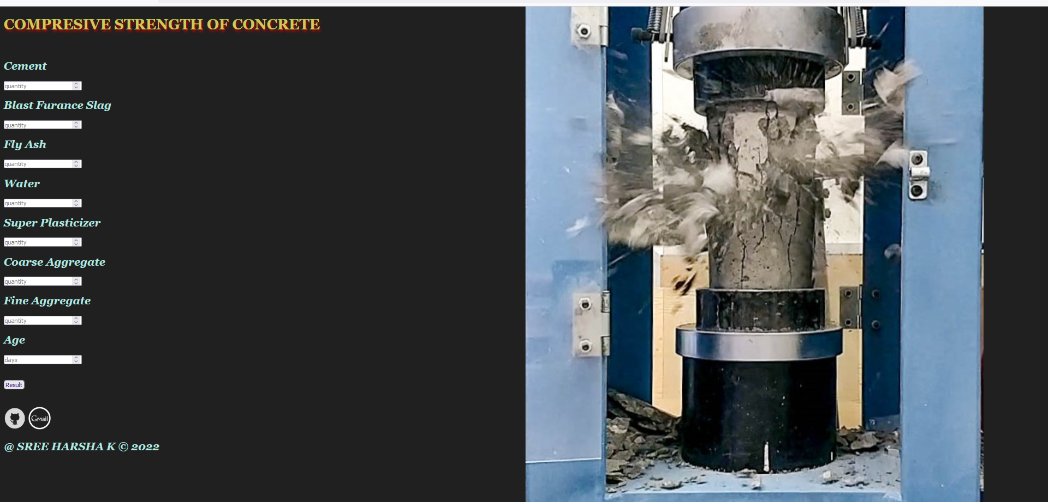

# Conclusion

Concrete Compressive Strength Predictor is used to predict the compressive strength of a concrete based on the given input quantities of raw materials used, which enables the engineers to determine its quality and saves a lot of time unlike the usual approach.

# References

* [Testing the compressive strength of a concrete in laboratory](https://www.youtube.com/watch?v=t4RDdn6rOwU&ab_channel=Anime_Edu-CivilEngineeringVideos)
* [Concrete Basics: Essential ingredients for a concrete mixture](https://concretesupplyco.com/concrete-basics/)
* [Applications of Fly ash](https://www.thespruce.com/fly-ash-applications-844761)
* [Blast furnace slag cement](https://theconstructor.org/concrete/blast-furnace-slag-cement/23534/)
* [Applications of Superplasitcizer in concrete making](https://en.wikipedia.org/wiki/Superplasticizer)
* [Factors that affect strength of concrete](https://gharpedia.com/blog/factors-that-affect-strength-of-concrete/)
* [Feature selection with sklearn and pandas](https://towardsdatascience.com/feature-selection-with-pandas-e3690ad8504b)
* [sklearn’s LassoCV](https://scikit-learn.org/stable/modules/generated/sklearn.linear_model.LassoCV.html)
* [Post pruning technique in Decision tree algorithm](https://towardsdatascience.com/3-techniques-to-avoid-overfitting-of-decision-trees-1e7d3d985a09)
* [Hyper parameter tuning in XGBoost](https://xgboost.readthedocs.io/en/latest/tutorials/param_tuning.html)
* [HTML, CSS tutorials](https://www.w3schools.com/)